*Music Store Data Analysis*

*By Ashin Sarkar*

***Problem statement:* The music store's database contains diverse and valuable information about its inventory, sales, customer preferences, and operational performance. However, extracting meaningful insights and answering specific business questions requires systematic analysis. This project aims to analyze the store's database by leveraging SQL commands to retrieve and process data efficiently. The objective is to address key business questions, uncover trends, and provide actionable insights to optimize inventory management, enhance customer satisfaction, and drive sales growth.**

**Q1: Who is the senior most employee based on job title?**

SELECT * FROM employee

ORDER BY levels DESC

LIMIT 1

***Output:-***



**Q2: Which countries have the most Invoices?**

SELECT COUNT(*) as c, billing_country

FROM invoice

GROUP BY billing_country

ORDER BY c desc

***Output:-***

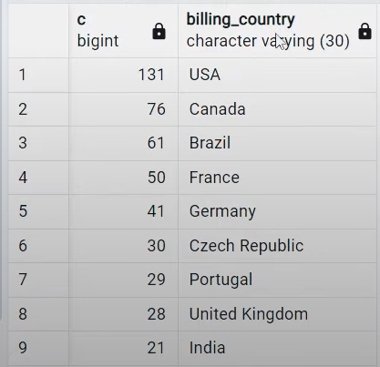

**Q3: What are top 3 values of total invoice?**

SELECT total

FROM invoice

ORDER BY total DESC

limit 3

***Output:-***

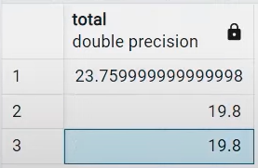

**Q4: Which city has the best customers? We would like to throw a promotional Music Festival in the city we made the most money. Write a query that returns one city that has the highest sum of invoice totals. Return both the city name & sum of all invoice totals.**

SELECT billing_city,SUM(total) AS InvoiceTotal

FROM invoice

GROUP BY billing_city

ORDER BY InvoiceTotal DESC

***Output:-***

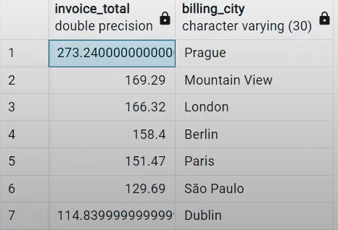

**Question 5: Who is the best customer? The customer who has spent the most money will be declared the best customer. Write a query that returns the person who has spent the most money.**

SELECT customer.customer_id, customer.first_name, customer.last_name, SUM(invoice.total) AS total FROM customer

JOIN invoice ON customer.customer_id = invoice.customer_id

GROUP BY customer.customer_id

ORDER BY total DESC

LIMIT 1

***Output:-***

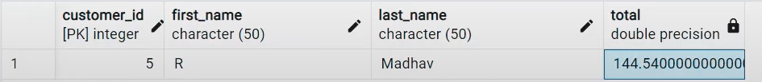

**Q6: Write query to return the email, first name, last name, & Genre of all Rock Music listeners. Return your list ordered alphabetically by email starting with A .**

***Method 1 :***

SELECT DISTINCT email,first_name, last_name

FROM customer

JOIN invoice ON customer.customer_id = invoice.customer_id

JOIN invoiceline ON invoice.invoice_id = invoiceline.invoice_id

WHERE track_id IN(

SELECT track_id FROM track

JOIN genre ON track.genre_id = genre.genre_id

WHERE genre.name LIKE 'Rock'

)

ORDER BY email;

***Method 2 :***

SELECT DISTINCT email AS Email,first_name AS FirstName, last_name AS LastName, genre.name AS Name

FROM customer

JOIN invoice ON invoice.customer_id = customer.customer_id

JOIN invoiceline ON invoiceline.invoice_id = invoice.invoice_id

JOIN track ON track.track_id = invoiceline.track_id

JOIN genre ON genre.genre_id = track.genre_id

WHERE genre.name LIKE 'Rock'

ORDER BY email;

***Output :-***



**Q7: Let's invite the artists who have written the most rock music in our dataset. Write a query that returns the Artist name and total track count of the top 10 rock bands .**

SELECT artist.artist_id, artist.name,COUNT(artist.artist_id) AS number_of_songs

FROM track

JOIN album ON album.album_id = track.album_id

JOIN artist ON artist.artist_id = album.artist_id

JOIN genre ON genre.genre_id = track.genre_id

WHERE genre.name LIKE 'Rock'

GROUP BY artist.artist_id

ORDER BY number_of_songs DESC

LIMIT 10;

***Output :-***



**Q8: Return all the track names that have a song length longer than the average song length. Return the Name and Milliseconds for each track. Order by the song length with the longest songs listed first.**

SELECT name,miliseconds

FROM track

WHERE miliseconds > (

SELECT AVG(miliseconds) AS avg_track_length

FROM track )

ORDER BY miliseconds DESC;

***Output :-***



**Q9: Find how much amount spent by each customer on artists? Write a query to return customer name, artist name and total spent .**

* Steps to Solve: First, find which artist has earned the most according to the InvoiceLines.Now use this artist to find which customer spent the most on this artist. For this query, we will need to use the Invoice, InvoiceLine, Track, Customer, Album, and Artist tables. Note, this one is tricky because the Total spent in the Invoice table might not be on a single product, so we need to use the InvoiceLine table to find out how many of each product was purchased, and then multiply this by the price for each artist.

WITH best_selling_artist AS (

SELECT artist.artist_id AS artist_id, artist.name AS artist_name, SUM(invoice_line.unit_price*invoice_line.quantity) AS total_sales

FROM invoice_line

JOIN track ON track.track_id = invoice_line.track_id

JOIN album ON album.album_id = track.album_id

JOIN artist ON artist.artist_id = album.artist_id

GROUP BY 1

ORDER BY 3 DESC

LIMIT 1

)

SELECT c.customer_id, c.first_name, c.last_name, bsa.artist_name, SUM(il.unit_price*il.quantity) AS amount_spent

FROM invoice i

JOIN customer c ON c.customer_id = i.customer_id

JOIN invoice_line il ON il.invoice_id = i.invoice_id

JOIN track t ON t.track_id = il.track_id

JOIN album alb ON alb.album_id = t.album_id

JOIN best_selling_artist bsa ON bsa.artist_id = alb.artist_id

GROUP BY 1,2,3,4

ORDER BY 5 DESC;

***Output :-***

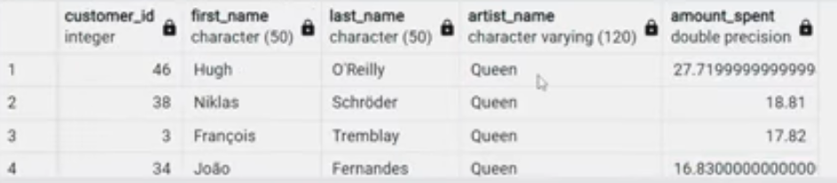

**Q10: We want to find out the most popular music Genre for each country. We determine the most popular genre as the genre with the highest amount of purchases. Write a query that returns each country along with the top Genre. For countries where the maximum number of purchases is shared return all Genres.**

* Steps to Solve: There are two parts in question- first most popular music genre and second need data at country level.

***Method 1:* Using CTE -**

WITH popular_genre AS

(

SELECT COUNT(invoice_line.quantity) AS purchases, customer.country, genre.name, genre.genre_id,

ROW_NUMBER() OVER(PARTITION BY customer.country ORDER BY COUNT(invoice_line.quantity) DESC) AS RowNo

FROM invoice_line

JOIN invoice ON invoice.invoice_id = invoice_line.invoice_id

JOIN customer ON customer.customer_id = invoice.customer_id

JOIN track ON track.track_id = invoice_line.track_id

JOIN genre ON genre.genre_id = track.genre_id

GROUP BY 2,3,4

ORDER BY 2 ASC, 1 DESC

)

SELECT * FROM popular_genre WHERE RowNo <= 1

***Method 2:* Using Recursive -**

WITH RECURSIVE

sales_per_country AS(

SELECT COUNT(*) AS purchases_per_genre, customer.country, genre.name, genre.genre_id

FROM invoice_line

JOIN invoice ON invoice.invoice_id = invoice_line.invoice_id

JOIN customer ON customer.customer_id = invoice.customer_id

JOIN track ON track.track_id = invoice_line.track_id

JOIN genre ON genre.genre_id = track.genre_id

GROUP BY 2,3,4

ORDER BY 2

),

max_genre_per_country AS (SELECT MAX(purchases_per_genre) AS max_genre_number, country

FROM sales_per_country

GROUP BY 2

ORDER BY 2)

SELECT sales_per_country.*

FROM sales_per_country

JOIN max_genre_per_country ON sales_per_country.country = max_genre_per_country.country

WHERE sales_per_country.purchases_per_genre = max_genre_per_country.max_genre_number;

***Output:***



**Q11: Write a query that determines the customer that has spent the most on music for each country. Write a query that returns the country along with the top customer and how much they spent. For countries where the top amount spent is shared, provide all customers who spent this amount .**

* Steps to Solve: Similar to the above question. There are two parts in question- first find the most spent on music for each country and second filter the data for respective customers.

***Method 1:* Using CTE -**

WITH Customter_with_country AS (

SELECT customer.customer_id,first_name,last_name,billing_country,SUM(total) AS total_spending,

ROW_NUMBER() OVER(PARTITION BY billing_country ORDER BY SUM(total) DESC) AS RowNo

FROM invoice

JOIN customer ON customer.customer_id = invoice.customer_id

GROUP BY 1,2,3,4

ORDER BY 4 ASC,5 DESC)

SELECT * FROM Customter_with_country WHERE RowNo <= 1

***Method 2:* Using Recursive -**

WITH RECURSIVE

customter_with_country AS (

SELECT customer.customer_id,first_name,last_name,billing_country,SUM(total) AS total_spending

FROM invoice

JOIN customer ON customer.customer_id = invoice.customer_id

GROUP BY 1,2,3,4

ORDER BY 2,3 DESC),

country_max_spending AS(

SELECT billing_country,MAX(total_spending) AS max_spending

FROM customter_with_country

GROUP BY billing_country)

SELECT cc.billing_country, cc.total_spending, cc.first_name, cc.last_name, cc.customer_id

FROM customter_with_country cc

JOIN country_max_spending ms

ON cc.billing_country = ms.billing_country

WHERE cc.total_spending = ms.max_spending

ORDER BY 1;

***Output:***

